1. Create user with name Techie and provide sudo access to user.
user name create as techie nd gave a password of this
2. Navigate to the home directory.

create a new directory
List the contents of a directory.
Change the current directory?
5. Change the current directory.
6) Create a new empty file.

7) View the contents of a file.
8.Copy a file to another location?
9.Move a file to another location.
10. Rename a file
11) Delete a file
12. Grant or revoke permissions on a file or directory.
13) View the current date and time.
14.Check the system uptime.
15) View the running processes.

16) Kill a running process.

17) Install a package using the package manager (e.g., apt or yum).

18) Update the system packages.

19) Create a symbolic link.
am using ln -s command
20) Search for files using the find command.
21) Compress and decompress files using tar.

22) Monitor system resources with top or htop.
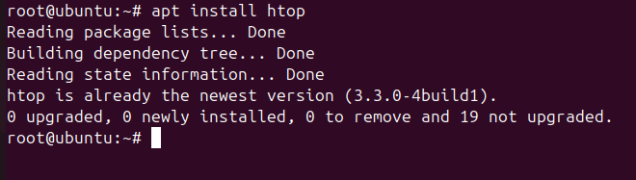

23) Create and manage user groups.

24) Set up SSH password less authentication.

25 .Monitoring log files using tail or grep.
i) Using log tail?
ii) Using gre
- Set up a web server (e.g., Apache or Nginx).
Install for nginx in ec2 browser
With yum install nginx
Then systemctl start nginx
Then systemctl status nginx
Here the result:
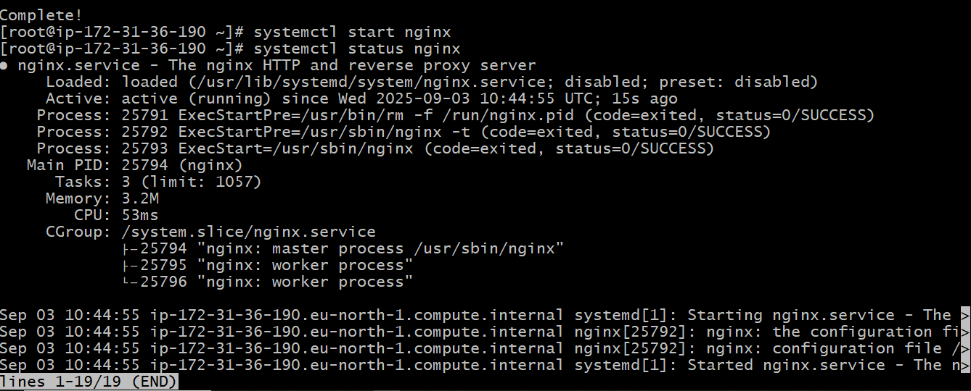
After that want to create a apache web server so want to stop the nginx then
Yum install httpd
Then systemctl start nd status
Here the results:

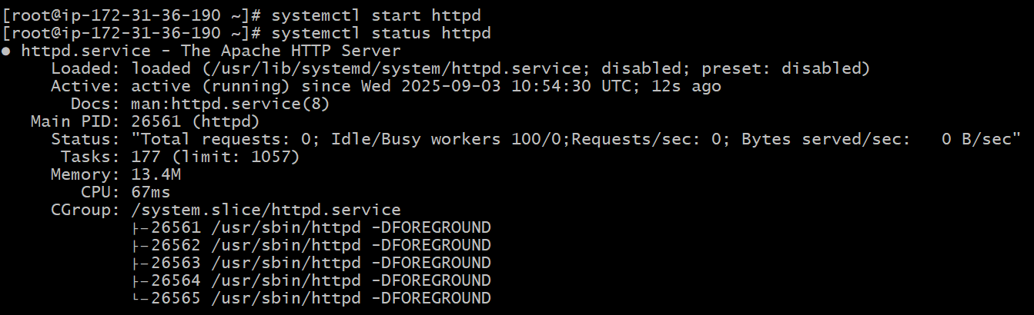
- Configure and secure a MySQL Database.

- Set up a Application Server (e.g.,Apache Tomcat)
if we want to set up application server tomcat
Firstly we need to do a yum java install then
Go to the official page of tomcat go to core take copy of link then wget that link paste here the results are:
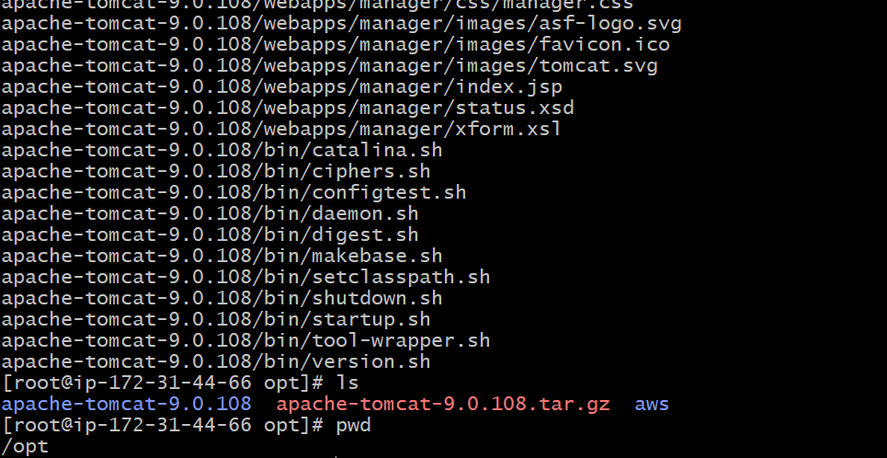
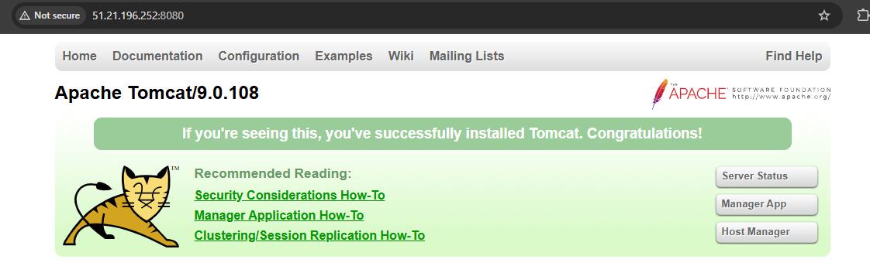
- create a service file for Apache Tomcat.(Should execute by using systemtctl command)
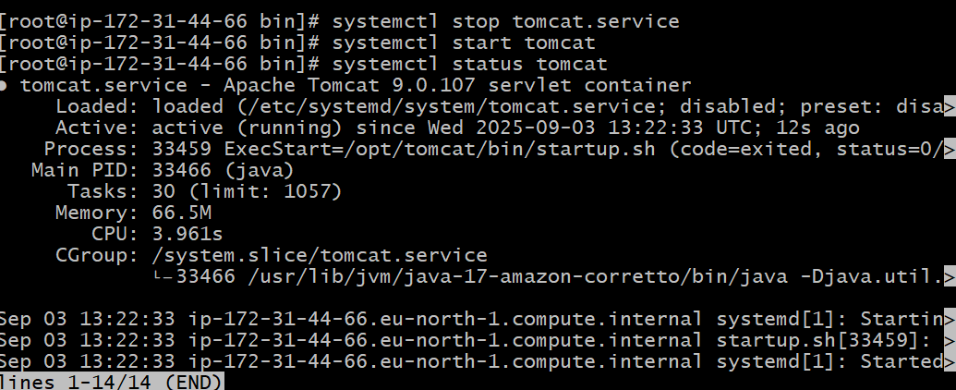

30) Print specific columns from a delimited file.

31) Filter and print lines based on a specific pattern or condition.

- Calculate and print the average, sum, or other statistics of a column.
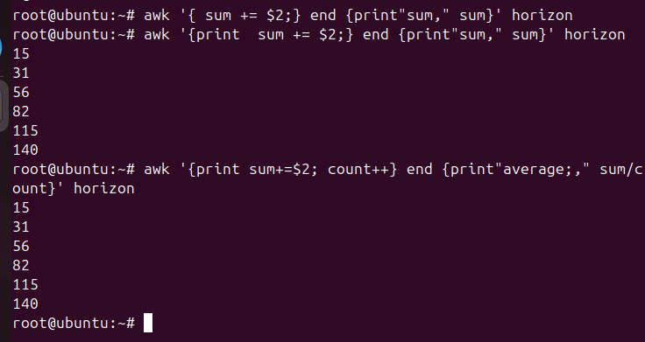

33) Perform string manipulation, such as extracting substrings or changing case.
34) Count the occurrences of a specific pattern in a file.
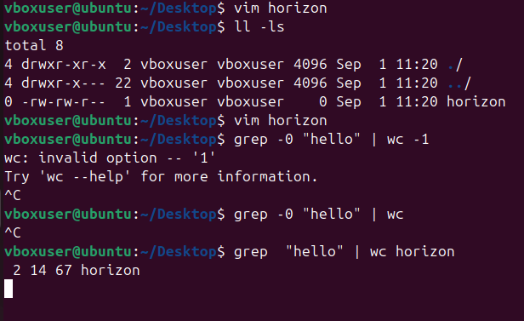
- Sort lines based on a specific field or column.
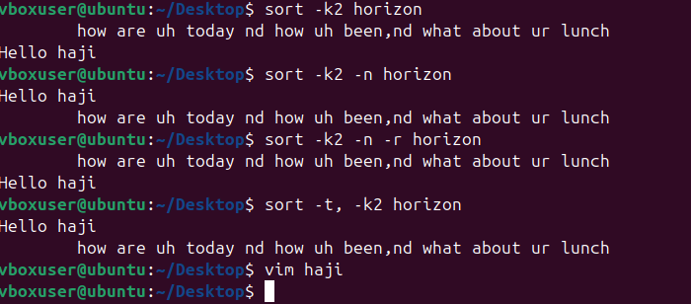
- Merge multiple files based on a common field or column.
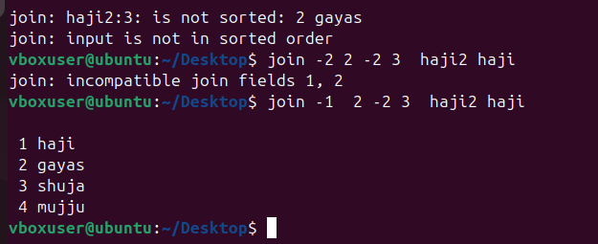
- Substitute text in a file using search and replace.
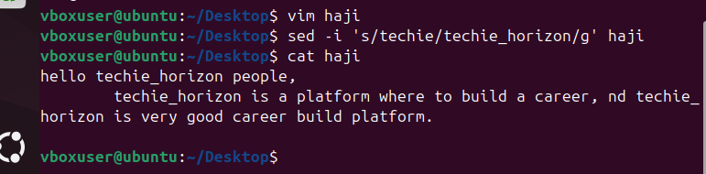
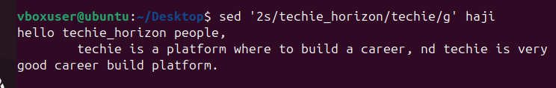
- Delete specific lines based on a pattern or line number.
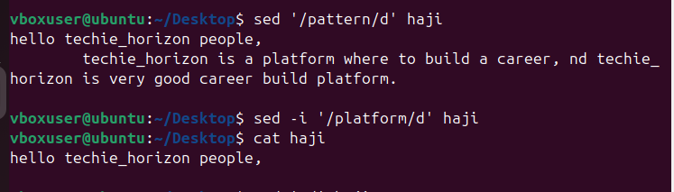
- Append or insert text before or after a specific pattern or line.
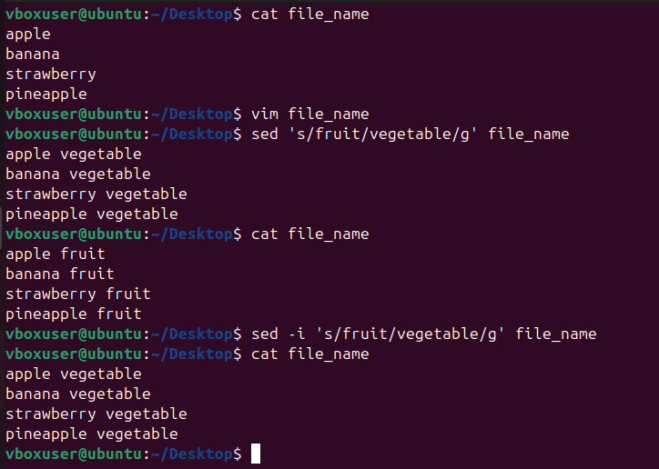

- Print only specific lines from a file.
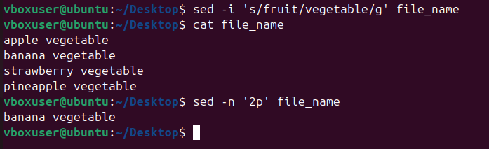
- Copy file from linux to windows machine

+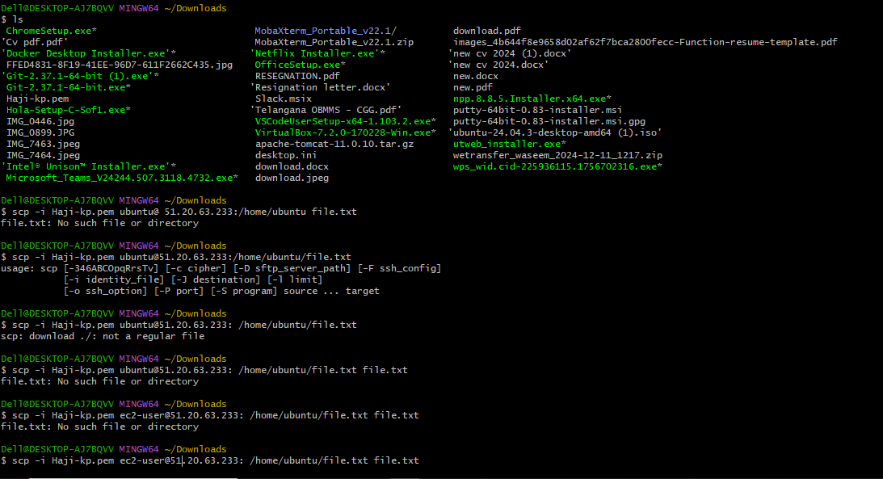

- 5 use cases for AWK and 5 use cases for sed
Field or column processing
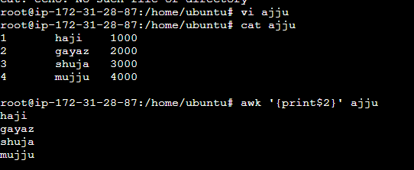
ii) Sum or average values in column
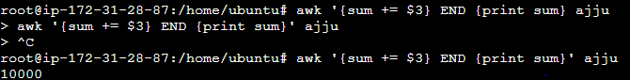
iii) Conditional processing
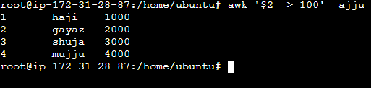
Iv) Formating Output
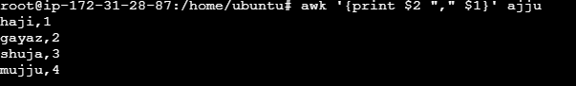
v) Multi file processing and join.
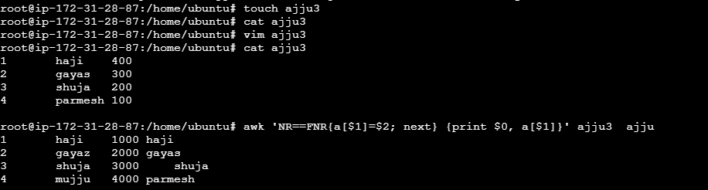
- Use cases for SED
- Search And Replace
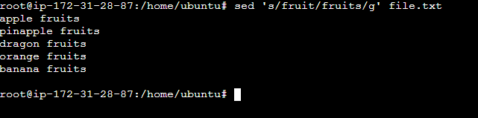
- Delete a line
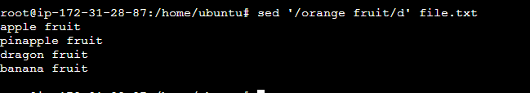
- Insert head before strt a line
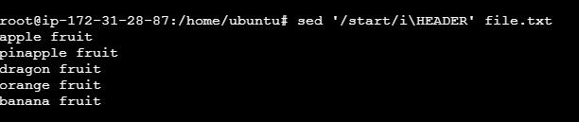

Iv) Extract specific lines
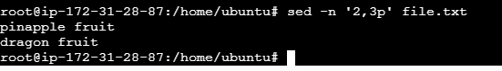
V) In place file editing
